***LASER HARP***

INTRODUCTION

A laser harp is an electronic musical user interface and laser lighting device. In this project description we will learn how to make a laser harp. It uses the variability of the resistance of an LDR(Light Dependent Resistor)to simulate musical notes. Musical notes of any instrument can be generated and the notes corresponding to various keys can also be set according to the likeness of the user .

CONCEPT:-

The aim of laser harp is to produce different musical notes of any particular instrument when the laser beams are interrupted by an obstacle, which in this case is our hands. The LDR output is monitored by a microcontroller , the microcontroller used in this project is Arduino Uno but Arduino Leonardo is more preferable as its use leads to less coding and more accurate note generation. Arduino Mega can be used to connect more LDR’s hence generate more notes. The output of LDR lies in the range of 0-1023, value of 1023 is achieved when laser beam is incident directly over the LDR, in general room conditions the value is <1000.Hence by monitoring this change in LDR output we can simulate musical notes when the laser beam is cut.

Materials Required: -

* Laser Pointer(Rs90) *(Equivalent to the number of notes you want to play)-Can be found at any general store
* Arduino Uno/Mega/Leonardo (Can be bought online)
* LDR (Equal to number of lasers)-At any electronics store
* Thermocol [According to design of harp]
* Battery(9V) *2[Laser lasts for more than a day ]
* Connecting wired [M2M, M2F, Jumper wires]
* Bread board
* 100K ohm Resistors (Equal to number of lasers)
* Chart Paper-To make harp more attractive
* Duct tape

***Construction:***

Initially we make a frame to hold the LDRs and lasers in position. The frame is rectangular in shape and is made up of thermocol, you can also use chart paper to make the harp look attractive. The ideal configuration is keeping the laser at the top and the LDRs at the bottom. Make as many number of holes equivalent to the number of lasers. Use a bread board to make the connections for the LDR and Arduino. [PHOTO]

Connect Arduino to a laptop. Place LDRs directly above the respective lasers. Upload a program to check LDR input and print it to Serial channel of baud rate 9600.Monitor the reading as it should be 1000> when the laser is turned on. Also check the values when the laser is turned off note those values for each and every LDR.

**CODING:**

For playing music we use a virtual keyboard. Take any virtual keyboard. The virtual keyboard play music when the keys of the keyboard are pressed. Hence to play notes using laser harp we have to simulate keypress when the laser beam is obstructed. This is possible directly by using Arduino Leonardo or mini , but not in any other boards .So to use this method in Arduino Uno we send the values to a python program which simulates key press. To make such a program firstly download pyserial module from the python website which contains functions to read serial values, also download pyautogui module which has functions to simulate keypress. Paste the modules in the main python folder to be able to import the modules. The Code to be used in python and Arduino are: -

PYTHON:-

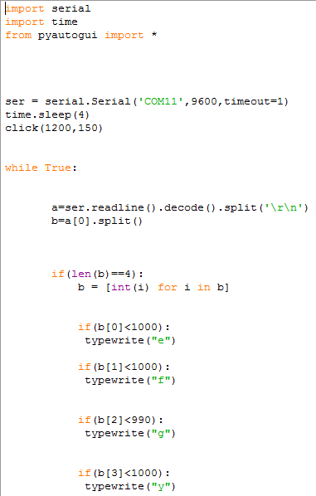

ARDUINO: -

int sensor1=A0; //input LDR 1

int sensor2=A1; //input LDR2

int sensor3=A2; //input LDR3

int sensor4=A3;

//values of sensors

int sensor1val;

int sensor2val;

int sensor3val;

int ;sensor4val

void setup() {

Serial.begin(9600); //sets serial port for communication

}

void loop() {

sensor1val=analogRead(sensor1); // read the value from the sensors

sensor2val=analogRead(sensor2);

sensor3val=analogRead(sensor3);

sensor4val=analogRead(sensor4);

Serial.print(sensor1val);//prints the values coming from the sensor on the screen

Serial.print("\t");

Serial.print(sensor2val);

Serial.print("\t");

Serial.print(sensor3val);

Serial.print("\t");

Serial.println(sensor4val);

delay (100);

}

You can change the Keys inside typewrite () function as to your liking. In **python** code b [0], b [1], b [2], b [3] are the value of the outputs of the first, second, third and fourth laser respectively. This code is for a laser harp of 4 lasers you can modify the code as you want to accommodate more lasers. The lighting of every room is different hence the output of the LDR is different for different rooms and also at different times of the day so modify the condition inside the if statement accordingly. It is recommended that the laser is to be kept in a dark room, then there is no need to vary the conditions. IMPNOTE-After executing the python code keep the virtual piano tab as the active window or else the code won’t work. I have used ***cdclan.6te.net/piano/index.htm*** for my harp as it has various instruments which the user can select which widens the scope of the harp.

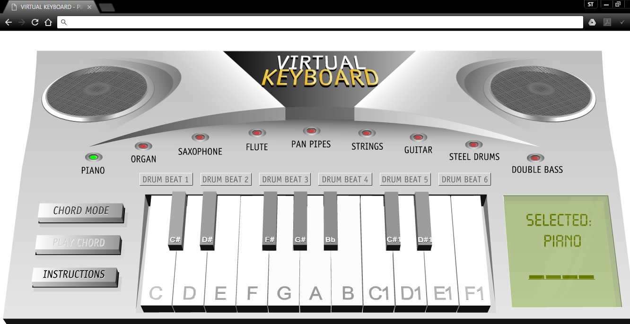

A speaker is also recommended with the laptop.

***Conclusion***:-

By following the above steps one can successfully create a laser harp. Various modifications can be brought to the code for a much faster response and accuracy. To make the laser beams visible use high power lasers in the presence of a smoke generator, to make it look more attractive. We can make it much more portable by modifying the design, solder the wires on a PCB to make it more durable and to reduce errors due to lose connections. Laser harp is a very interesting, user interactive project that everyone would love to use.Here’s the picture of the final product that I got

